***Cover Letter***

Md. Akhtaruzzaman

Akhtaruzzaman561@gmail.com

E-mail:

Cell: +880 1722-696699

Dear Sir,

Recently I have come to know about the job opportunity in your organization. The aforementioned job and the prospect of working at your organization seemed to be very attractive to me. So, I am very interested to join in your organization as a responsible personnel & buildup my professional career. I also have attached my CV for your kind consideration.

As you will see from my CV, I have completed MBA major in Accounting and Information Systems. As the stream suggests, I have studied accountancy with a special focus on International Accounting Standards, which is relevant for the accounting & administration of an organization like yours.

I would be delighted if I have been given an opportunity to work with your organization. I feel I would be able to make a significant contribution towards the company's overall objective.

If you need any further information, I will have been ready to response any time.

Sincerely Yours,

*Akhtaruzzaman*

**Curriculam Vitae Of Akhtaruzzaman**

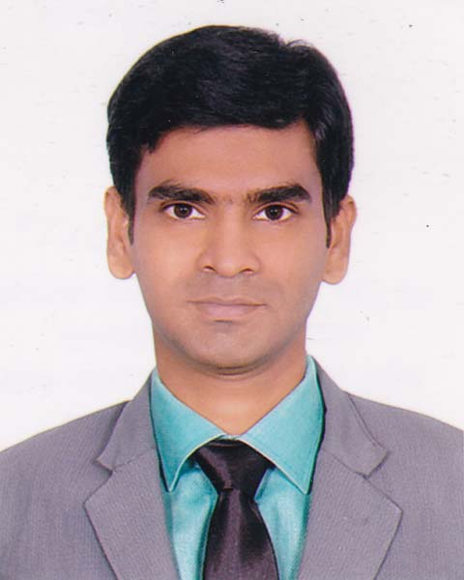

**PRESENT ADDRESS**

**House-48/B, Road-Chandrima Sharak, West Shawrapara,**

**Mirpur, Dhaka- 1216**

**BD15155_Contact No. : 01722696699, 01553386694  
E-mail : akhtaruzzaman561@gmail.com**

**CAREER OBJECTIVE**

Capacity and willingness to work under stress and competitive environment requiring sense of responsibility, commitment, poise, hard work and focus on Business Administration with potential avenues for learning and growth.

**EDUCATIONAL QUALIFICATION**

* **Masters of Business Administration (MBA)**

Name of Institution : University of Dhaka

Concentration : Accounting & Information System

Result : CGPA 2.97 (Scale-4)

Passing Year : 2019

* **Bachelor of Business Administration (BBA)**

Name of Institution : Joypurhat Govt. Collage,Joypurhat

University : National University

Concentration : Accounting

Result : CGPA 3.05 (Scale-4)

Passing Year : 2013

* **Higher Secondary Certificate (HSC)**

Name of Institution : Amdoi United Degree Collage

Education Board : Rajshahi

Group : Commerce

Result : GPA 4.10 (Scale-5)

Passing Year : 2009

* **Secondary School Certificate**

Name of Institution : Madhainagar B.L. High School

Education Board : Rajshahi

Group : Humanities

Result : GPA 4.44 (Scale-5)

Passing Year : 2007

**EXPERIENCE**

* Accountant-Your Travel Ltd.- Banani-11,Dhaka-1213.
* Assistant Manager (Accounts)-S.S. International, Kolabagan, Dhanmondi, Dhaka-1205.
* Program Coordinator- Udvash-Unmesh Education Family-Farmgate, Dhaka-1215.
* Account Assistant-Brac Bank Ltd (SME)-Joypurhat Branch, Joypurhat.

**INTERNSHIP**

* Successfully Completed Internship At **MEGHNA GROUP OF INDUSTRIES** on **FMCG Accounts** for **3** months.**(22.10.2018 to 23.01.2019)-** Gulshan-1, Dhaka-1212.

**COMPUTER SKILLS**

1. Operating System : Linux, Windows 98, XP, Seven, Vista, 10
2. Application Package : MS. Word, MS. Excel & MS. PowerPoint.
3. Database : MS. Access
4. Hardware : Computer Hardware Setup & Setting, Windows Trouble Shooting
5. Internet and Web : Good commend on internet browsing (like conducting web

chats, emails etc.)

**TRAINING SUMMARY**

* Basic training on **SAP & Tally ERP 9**.
* Completed training on **Foundation Skills** under **Bangladesh Youth Development Department.** (July2013 to Dec.2013)
* Have a good command on **Microsoft Word**, **Excel, Power Point**, **Internet Applications**,and other general applications.
* Have the ability to write and speak fluently in both **Bengali** and **English** language.

**LANGUAGE PROFICIENCY**

1. Bengali : Mother Language
2. English : Good command in speaking, listening, reading and free hand writing.

Hindi : Conversational

**ADDITIONAL INFORMATION**

* **Team Member:** Have ability to lead a team or work as a good team member for any relevant work areas.
* **Outgoing & Achiever:** Ready to do the assigned work and have the courage and ability to achieve the goal.

**INTEREST**

* Travelling, Reading and Watching Movies

**PERSONAL INFORMATION**

Name **:** Md. Akhtaruzzaman

Father’s Name **:** Abu Hayat Md. Shamsuzzaman

Mother’s Name **:** Rubina Begum

Date of Birth **:** August 9, 1991

Marital Status **:**  Single

Religion **:** Islam

Nationality **:** Bangladeshi (By Birth)

NID No. **:** 8209431777  
 Permanent Address **:** Village: Madhinagor, Post: Amdoi, Thana: Jaipurhat,

Dist.: Jaipurhat.

**REFERENCES**

1. Md. Gainal Abedin (Biddut) 2. Md. Siddiqur Rahman

Advocate FAVP

Jurists, Advocate & Consultant Mercantile Bank Ltd

Biddut & Associates Motijheel, Dhaka-1000.  
 45, Tropicana Tower, Old Paltan Mobile no: 01817095568

Dhaka-1000



------------------------------------

Signature